

**BEACONHOUSE NATIONAL UNIVERSITY**

**Wasail**

**PRJ-F23/333**

**REQUIREMENT ANALYSIS DOCUMENT**

**EXTERNAL SUPERVISOR**

**Hamza Zafar**

**INTERNAL SUPERVISOR  
  
Huda Sarfraz**

**GROUP MEMBERS**

**Fatima Ali Tirmizi F2020-718**

**Fizza Adeel F2020-336**

**Irtaza Ahmed Khan F2020-153**

**Malaika Sultan F2020-661**

**SCHOOL OF COMPUTER & IT**

**Table of Contents**

**Introduction 3**

**Existing Systems 3**

**Literature Survey 9**

**Requirement Gathering and Fact Finding 10**

**Software Requirement Specification (SRS) 13**

System Environment 13

User Roles 13

User Stories (Grocery Store) 14

User Stories (Vendor) 16

User Stories (Site Admin) 16

Functional Requirements 16

Grocery Store and Vendor (FR1) 16

FR1.1: Language Selection 16

FR1.2: Phone Registration 17

FR1.3: Phone Number Confirmation 18

FR1.4: OTP Code Generation and Delivery 19

FR1.5: Login 20

FR1.6: Logout 20

FR1.7: Reset Password 20

FR1.8: View Profile 21

Grocery Store (FR2) 22

FR2.9: Account Details 22

FR2.10: Search Product 22

FR2.11: Search Vendor 23

FR2.12: Browse Category 24

FR2.13: View Vendor Profile 25

FR2.14: Add Vendor to Vendor List 26

FR2.15: Contact Vendor 26

FR2.16: View Products on the Vendor’s profile 26

FR2.17: View Searched Product 27

FR2.18: Select Products 27

FR2.19: Order Recommendation 28

FR2.20: Quantity Selection 28

FR2.21: Remove Product 29

FR2.22: Order Placement 29

FR2.23: View Order 29

FR2.24: Order Tracking 29

FR2.25: View Order History 30

FR2.26: View Vendor List 30

FR2.27: Edit Profile 30

FR2.28: Notification 30

Vendor (FR3) 36  
 FR3.9: Search Product in Inventory 36  
 FR3.10: Add Product to Inventory 37  
 FR3.11: All Products Search 38  
 FR3.12: Remove Product 39  
 FR3.13: Edit Details of Product 40  
 FR3.14: View Inventory 41  
 FR3.15: View Current Orders 42  
 FR3.16: View Grocery Stores List 43  
 FR3.17: View Grocery Store Profile 44  
 FR3.18: View Grocery Store Current Order 45  
 FR3.19: View Orders History 46  
 FR3.20: Edit Profile 46  
 FR3.21: Order Dispatch Tracking 47  
 FR3.22: Restrict Product Duplication 47

Non-Functional Requirements 31

**Test Cases 32**

**Machine Learning Requirements 34**

**References 37**

# Introduction

Inefficiencies, wastage and imprecise demand forecasting due to traditional inventory management processes have been an emerging challenge in the landscape of the food industry, specifically the supply chain system. There is a dire need for digitisation and automation within the industry, as evident by businesses’ inability to streamline processes, predict demand accurately, and optimise resource usage. This deficiency hinders the possibility of an agile and responsive supply chain that is essential for navigation in today’s data-driven decision-making.

In response to the aforementioned issue, our proposed solution aims to address current vulnerabilities in the supply chain i.e. grocery and vendor retail domain by providing a technological solution, more specifically advanced data analytics using Machine Learning (ML), to create a transformed order management and distribution system. This will be done through an accurately predicted customer demand, owing to a demand forecasting system, having utilised sales, holiday, location, exchange rate (or fuel prices), and weather data.

The system will be integrated into a mobile-based platform connecting grocery stores with vendors to enable an efficient and profit-maximising operationality. An intuitive platform design of a platform such as ours would assist sales and purchase of goods by reducing physical visits made by vendors and enhancing operational efficiency through a tracking feature for grocery stores. Novice grocery stores would be assisted in searching for specific products from reliable registered vendors.

This platform stands out from *Tajir, Dastgyr, Jugnu, Bazaar, and Retailo* with the aid of a ML based demand forecasting system. This move toward modernisation and automation sets it apart in pursuing the same goal. As efficiency and accuracy arise in the inventory management, the precision by ML will allow stores to order optimal quantities, mitigating risks of overstocking and understocking.

This approach, inspired by the insights presented in 'Advances in Supply Chain Management' [1], aims to redefine forecasting, curb waste, and optimise operational efficiency for grocery stores and vendors. Ultimately, the solution would strive to augment overall profitability in the food industry and create a smarter supply chain system.

# Existing Systems

In the current supply chain scenario in Pakistan, the movement of products relies heavily on outdated and paperwork-intensive processes. This traditional approach poses significant challenges, including vulnerability to disruptions, limited visibility due to infrastructure constraints, and communication hurdles. Retailers face stockouts, unpredictable supply arrivals, and a slow replenishment process, leading to operational inefficiencies and working capital restrictions. The conventional procurement structure demands substantial time investment, with retailers spending an average of 25 hours per week navigating wholesale markets [2].

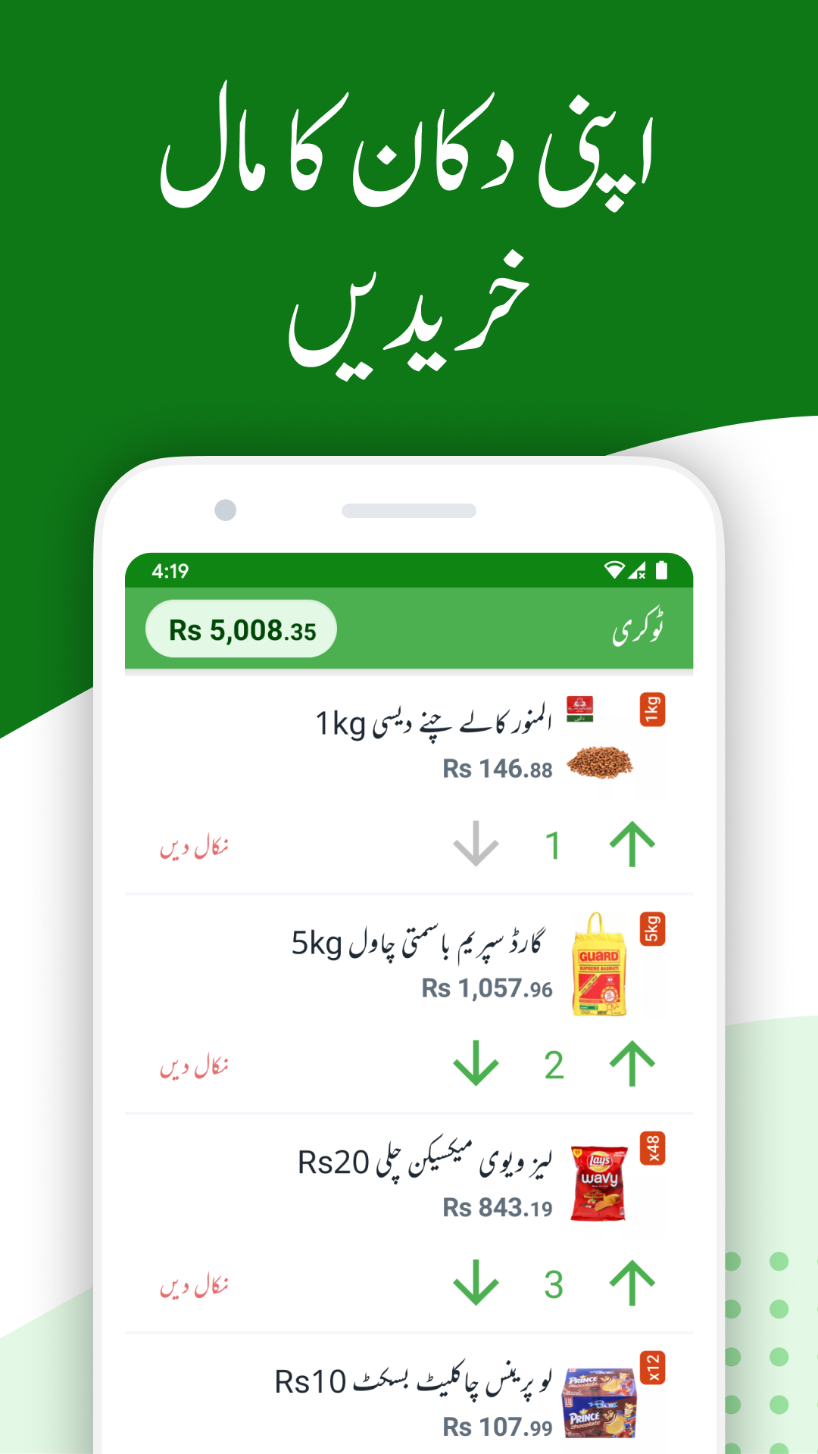

A notable player addressing these challenges is **Tajir**, a platform revolutionising inventory management for mom-and-pop stores in Pakistan. Tajir acts as a vendor, offering a seamless solution for purchasing inventory. It enables retailers to order at their convenience, receive on-demand deliveries, access transparent pricing, and choose from an extensive product selection. Inspired by successes like Tajir, our proposed software solution aims to complement and enhance the existing landscape by providing unique features tailored to the specific needs of small and medium retailers in Pakistan.

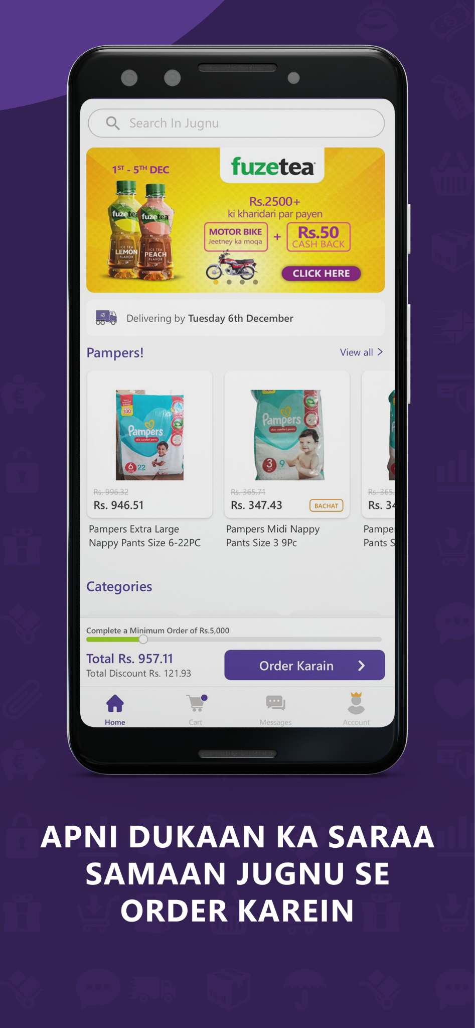

Adding to this is **Jugnu**, a Business to Business (B2B) e-commerce platform founded in 2020. Jugnu strives for social and economic empowerment by connecting large suppliers to small and medium enterprises, driving growth in local economies. The platform operates across major cities in Pakistan, offering a user-friendly platform for ordering and receiving deliveries within a 24-hour window.

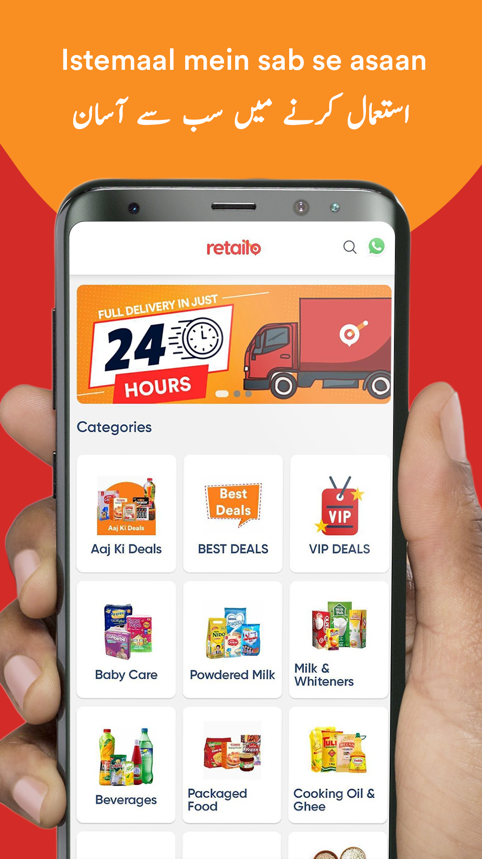

**Retailo**, another B2B marketplace, allows retailers to restock their shops conveniently with features like instant price comparisons and next-day delivery, eliminating the need for multiple distributors and weekly restocking hassles.

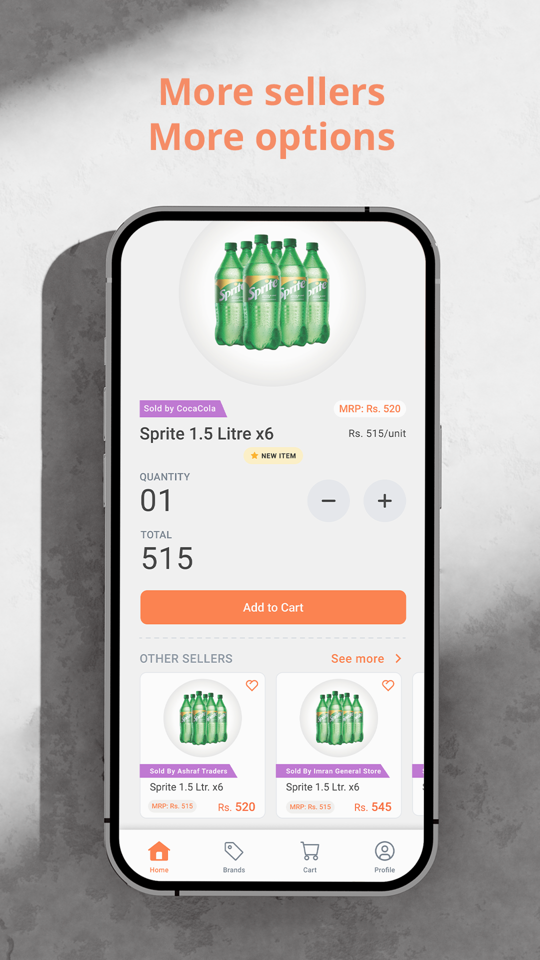

**Dastgyr**, another B2B marketplace, addresses the pain points of small retailers by connecting them with manufacturers and suppliers. It offers a one-stop solution for inventory needs, allowing retailers to place orders in seconds and receive on-demand delivery. Additionally, retailers working with Dastgyr for three months become eligible for credit purchases, addressing the challenge of limited access to external capital for growth.

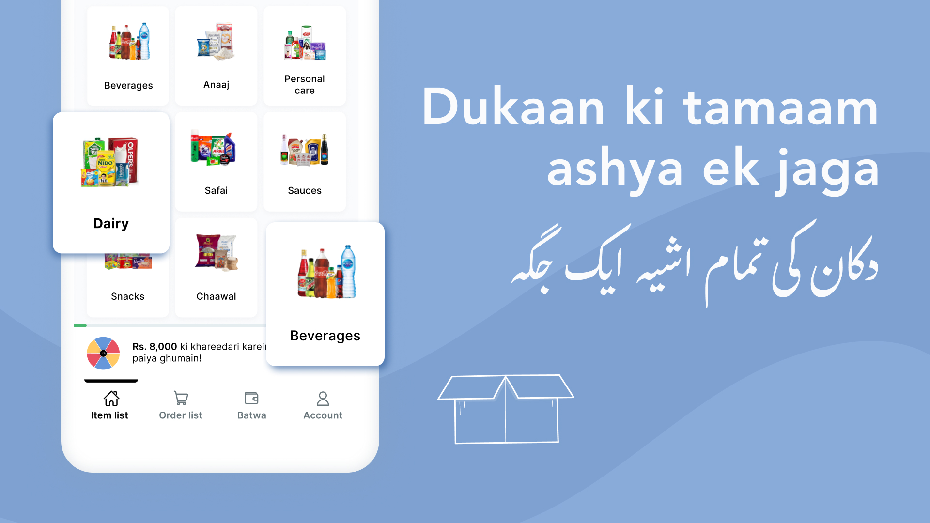

Next is **Bazaar** which contributes to digitising and growing businesses in Pakistan through its mobile app, providing small business owners access to a wide assortment of goods with free next-day delivery.

Additionally, we also explored **Candela RMS**, an enterprise retail software solution focusing on inventory management and POS for all kinds of retail. Candela RMS offers features like ‘*Manage Inventory Shrinkage*’ which is essentially a reorder level feature that sends an alert when an item in the inventory reaches a lower limit and ‘*Edibles Expiry Management’* another feature that allows the entry of expiration dates during stock entry and subsequently printing the expiry date along with the barcode. While this feature aids in managing the expiration of products, it doesn't directly address the nuanced challenge of demand forecasting.

As we undertake this software solution project, we draw insights from the successes of these platforms, aiming to contribute to the modernisation and resilience of the supply chain ecosystem in Pakistan. Our market survey and research findings indicate a gap in the current solutions, with a need for a system that not only helps manage inventory but also accurately predicts demand and facilitates smooth communication between grocery stores and vendors. By incorporating elements from these innovative solutions, we seek to offer a comprehensive and effective software solution tailored to the specific challenges faced by small and medium grocery store retailers in the country.

# 

# Literature Survey

In addressing the multifaceted challenges of the food industry, recent studies have illuminated innovative solutions, offering insights that span crucial domains. One study explored the effectiveness of high-tech inventory management within supermarkets, attributing a significant 56.7% of their performance to automation [3]. Another research framework proposed the strategic implementation of AI and robotics to combat food loss during the pandemic, emphasising sensory enhancement and collaborative automation [4].

Recent advancements in deep learning, as highlighted in various studies, signal a transformative shift in the landscape of demand forecasting. Techniques such as multi-modal sales forecasting networks and the application of LSTM demonstrate superior accuracy and effectiveness [5, 6]. The debate between traditional and machine learning forecasting emerges, with a study showcasing the promise of a support vector machine in handling multiple demand series [7].

A groundbreaking study utilised low-cost sensors and machine learning to achieve a remarkable 92.65% accuracy in predicting for preventing food wastage, addressing a critical concern in the industry [8]. Global food supply chains are explored in another study, emphasising the importance of efficiency and behaviour change, particularly in affluent economies, to combat waste [9]. Strategies for proactive food waste reduction in the grocery sector are elucidated in a study that carefully balances customer satisfaction and inventory management [10].

The evolving role of e-grocery as an alternative to traditional retailing is highlighted, emphasising in-stock availability in customer decisions [11]. Generalised Additive Models for Location, Scale, and Shape (GAMLSS) are recommended in another exploration, specifically focusing on-demand distribution tails in e-grocery [12]. A simulation model dissects the benefits and drawbacks of Vendor-Managed Inventory (VMI) in the grocery supply chain, revealing that manufacturers reap more significant benefits from VMI adoption [13].

The chocolate industry is subject to a study employing machine learning for refined predictions based on regular and promotional sales data [14]. Retail firms, including Walmart, Costco, and Kroger, are analysed as economic indicators through statistical regression and machine learning, exposing operational inefficiencies [15]. The study on 'Corporacion Favorita,' a major grocery chain in Ecuador, offers insights into optimising predictions and mitigating stock-out and over-stocking issues [16].

In addition, abroad there are platforms like **Shelf Engine** and **Guac**, both leveraging machine learning for demand forecasting and order optimisation in the grocery retail sector. The major difference lies in their approach; Guac provides recommendations, leaving the final order decision to stores, while Shelf Engine actively decides orders and assists in placing them with vendors. Drawing inspiration from global industry trends, our proposed system aligns with the approach of Guac, aiming to leverage technology, embrace automation, and address current vulnerabilities in our supply chain. Despite notable progress in these studies and platforms, challenges such as training set size, overfitting, and model complexity persist, necessitating further exploration for the development of a responsive and sustainable food system.

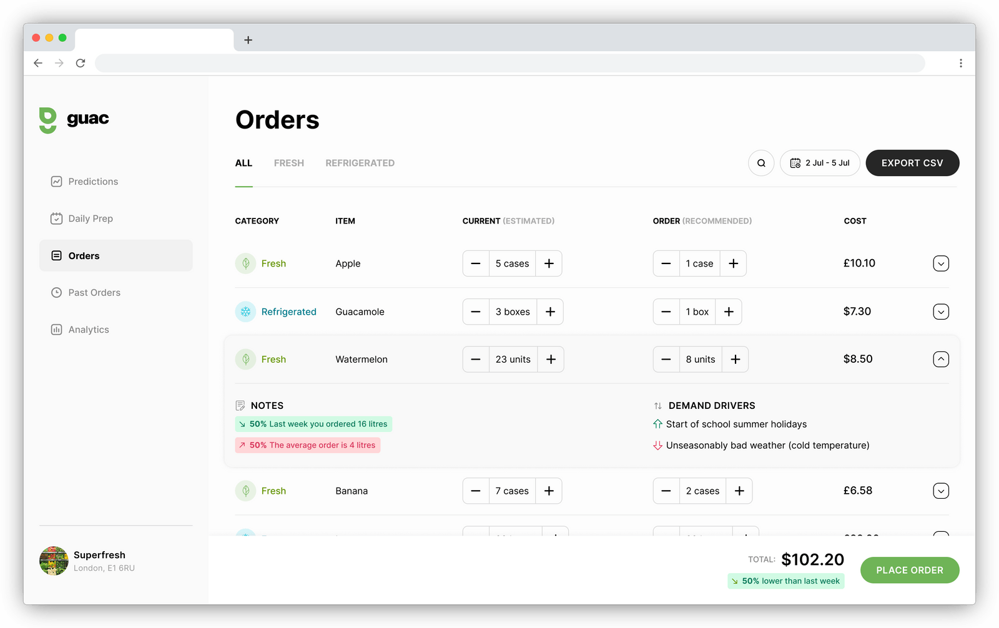

# Requirement Gathering and Fact Finding

We engaged grocery stores through unstructured interviews (transcripts in Appendix) and navigating the stores to discuss concepts like strategic shelf placement for marketing and promotion.

**Data Collection Technique:** Interviews and Observation

***Reasoning*:** Interviews provide a strategic and adaptable approach, capturing detailed, context-specific information essential for understanding the challenges faced by grocery store owners in the supply chain.

**Issues Identified**

Amongst the challenges found, an outdated ordering system is the biggest one. This manifests in discounted products nearing expiration which raises concerns over quality and safe use, and monopolisation of certain products where grocery stores do not allow specific products to be sold by vendors to any other grocery store than them e.g. a grocery store in a housing society tells the vendor that they will only purchase a specific product if the vendor does not sell it to any other store in that housing society. In-person interviews highlighted the impact of these issues, emphasising that existing tools (inventory management systems and point of sale systems) are rendered ineffective due to their complexity. Even grocery store workers who are tech-savvy try to avoid inventory-related tasks, such as adding received inventory. They only use it for selling as it makes the process of selling faster and more convenient for them. Notably, the grocery store workforce is not technologically inept; rather, the current inventory systems are user-unfriendly. There is also an issue of ‘*mobilers*’, a community term for individuals that are fake/pretend vendors selling either fake or expired products.  
 **Summarised**

An outdated ordering system that has consequences such as:

* Existing tools are too difficult to use for grocery stores
* ‘Mobilers’ selling fake or expired products
* Limited vendor options for new products discoverability
* Product Monopolisation

**Interview Insights**

Insights into the ordering process included manual observation of daily sales i.e. qualitative analysis by the grocery store owner to decide the quantity for the next order, with budget constraints such as inflation leading to reduced stock purchases. Some grocery stores do not have access to specific products by a shared vendor on demand of another grocery store.

On the digital frontier, software challenges include a dependency on electricity, a lack of backup during power outages, and manual data entry during disruptions. The workforce's adeptness with technology clashes with the current software's complexity, leading to underutilization.

**Summarised**

1. Ordering Process:

* Qualitative analysis to determine order quantities
* Budget constraints impact stock purchasing decisions
* Limited access to specific products due to shared vendor restrictions (grocery stores restricting vendors to only sell a specific product to them)

1. Software Issues:

* Dependency on electricity for software usage
* Lack of backup in case of power outages
* Manual data entry during power disruptions

**Conclusion:** The insights gathered through interviews with grocery stores highlight critical issues in the current supply chain, forming a crucial foundation for the development of our software solution. The experiences shared by Z Mart, Express Store, and My Store underscore the necessity for a digital solution to tackle challenges related to order management, inventory control, and system reliability. Furthermore, the additional research reveals significant gaps in the existing mechanisms, including the absence of a formal communication channel with vendors, authentication issues, and a reliance on your vendors as the sole source for new products.   
 **Potential Improvements & Proposed Solution:**

* **Demand Forecasting and Automation:** Develop a sophisticated system for demand-forecasting, integrated in a platform managing orders and distribution, supported by machine learning and use variables like sales trends, weather, location, and holidays, optimising the inventory management.
* **Waste Reduction and Profitability Augmentation:** Redefine forecasting to curb food wastage whilst optimising operational efficiency for both grocery stores and vendors. As sales increase so does profitability.
* **Streamlining Processes:** Introduce an easier-to-use system for a seamless user experience.
* **Increased Visibility:** Enhance vendor lookup and search functionalities.
* **Collaborative Platform:** Verify the legitimacy of vendors for a secure collaborative environment and reduce physical visits to grocery stores by vendors through the platform.

# Software Requirement Specification (SRS)

## System Environment

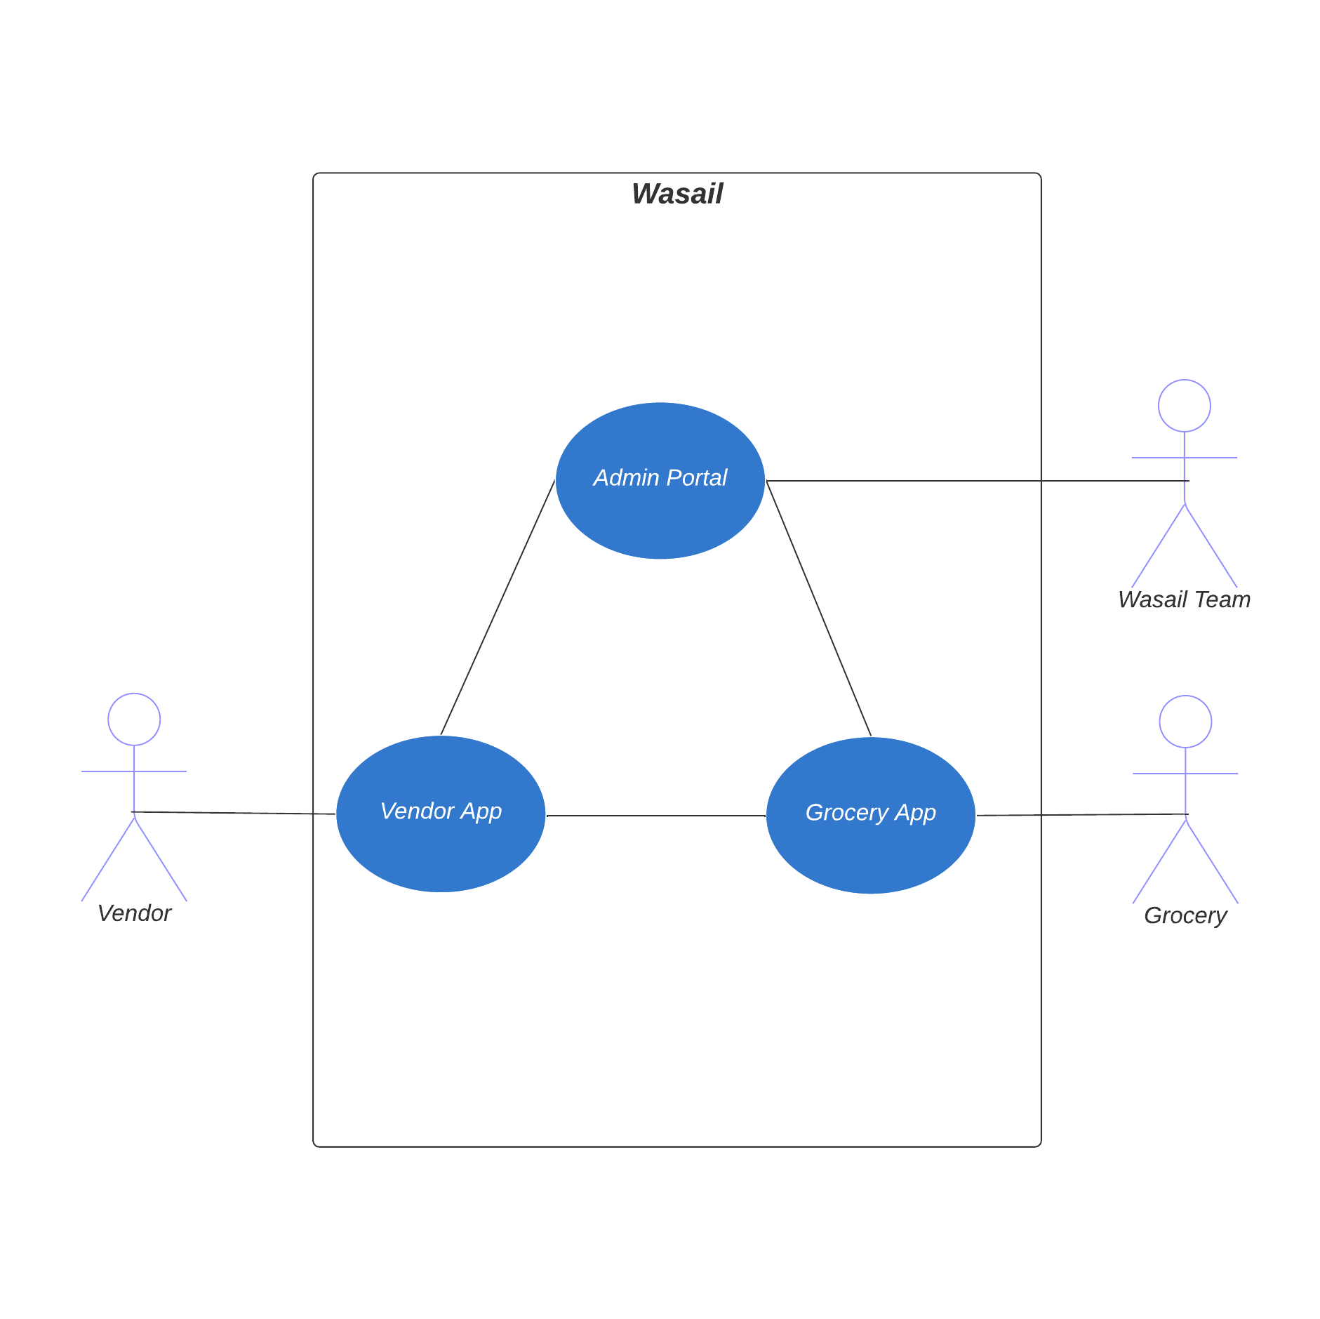

## User Roles

The grocery store app has the following user roles:

* Grocery Store: A user who is looking for a product for their store.
* Vendor: A user who is selling the products to the grocery store.
* Site Admin: A user who is part of the developer team

Future Improvement:

* Convert “Grocery Store” actors into two actors: “Owner” and “Employee”

## User Stories (Grocery Store)

**User Story: Placing the Order**

As a grocery store, I would want to place an order for a product while receiving a recommended amount to order.

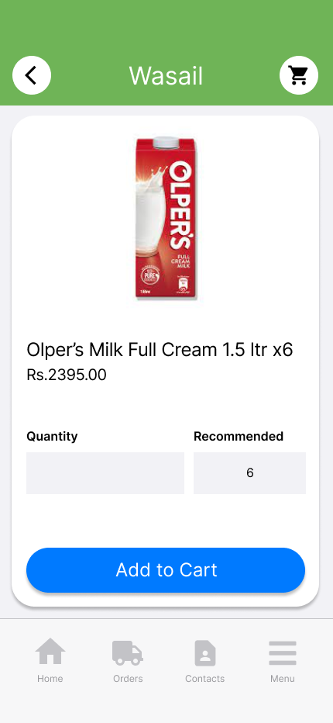

**Acceptance Criteria:**

* Once I have clicked on the vendor’s profile, the app should display the vendor's details which should include the contact information, the product listings, and an option to connect (future improvement: ratings and reviews).
* While I'm on the vendor’s profile, the app displays the product that I have searched for under the “Searched Product” section, and the other products the vendors sell under the “Popular Products” section.
* I can click on the product I want to order, and the app will take me to another screen where I will be able to select the quantity of the product.
* A recommended amount to order would be displayed.
* I should be able to order the recommended amount or enter the amount to order myself.
* Once I have filled out the aforementioned criteria, I would select the “Add to Cart” button and my order would be added to the cart.
* Then, I can open the cart and place the order.

**User Story: Searching for a Product**

As a grocery store, I would like the ability to look up products online.

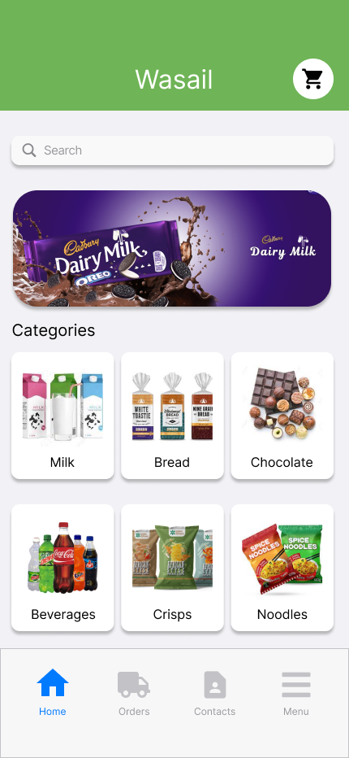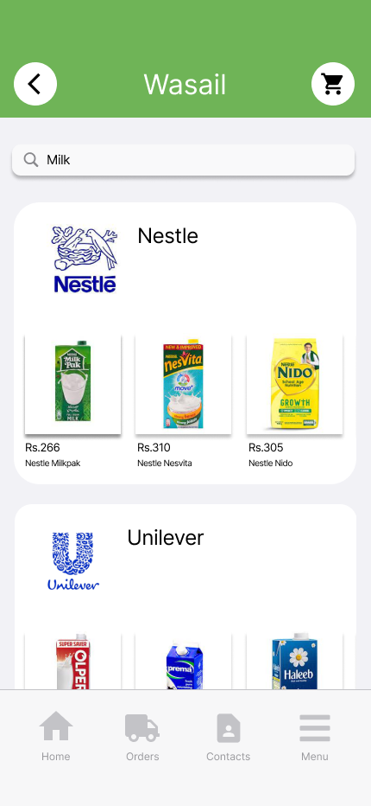

**Acceptance Criteria:**

* When I log into the app, I should see a search bar on the main screen along with popular categories.
* I can search the product by the name of the product (e.g. Milkpak), category of the product (e.g. Milk), and other suggestions as alternatives.
* After entering a search term, the app should present a list of vendors offering the product I need (along with the products), taking into account their ability to deliver to my store's location.
* The vendors on my connection list who fulfil the aforementioned criteria should be displayed at the top, and the rest of the vendors should be displayed after them.
* I can click on the vendor’s profile to view more details.
* (Future improvement: Sorting by price low to high, ratings, orders completed, etc)
* (Future improvement: Be able to filter products based on quantity such as a pack, half a pack or individual items, amount of litres of bottles, etc)

## User Stories (Vendor)

## User Stories (Site Admin)

## Functional Requirements

This section details functional requirements for:

* Grocery Store Mobile App (28)
* Vendor Mobile App (22)
* Admin Web App

### Grocery Store and Vendor (FR1)



#### FR1.1: Language Selection

* **Description**: The system should allow the user to select a language.
* **Actor**: Grocery Store, Vendor
* **Precondition**: The user has not specified their preferred language for displaying the text in the app.
* **Postcondition**: The user has specified the language.
* **Details**:

1. The user is given the option to select a language.
2. The options that they can select from are English, Roman Urdu, and Urdu.
3. The user’s choice for language is stored in the database.

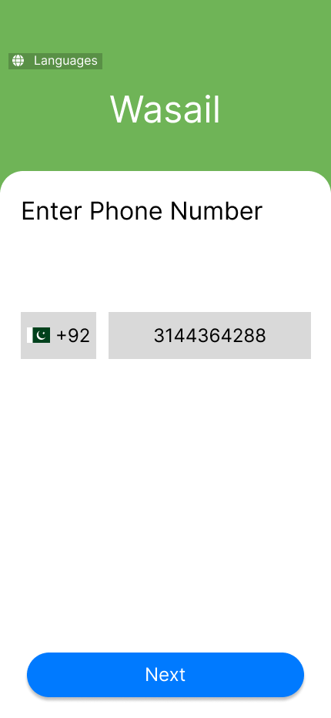

#### **FR1.2:** **Phone Registration**

* **Description**: The system should allow users to create an account using their phone number.
* **Actor**: Grocery Store, Vendor
* **Precondition**: The user is not registered in the system.
* **Postcondition**: The user is directed to the phone number confirmation screen.
* **Details**:

1. User would provide a valid phone number.
2. The system validates the phone number format ensuring that it has been entered correctly.

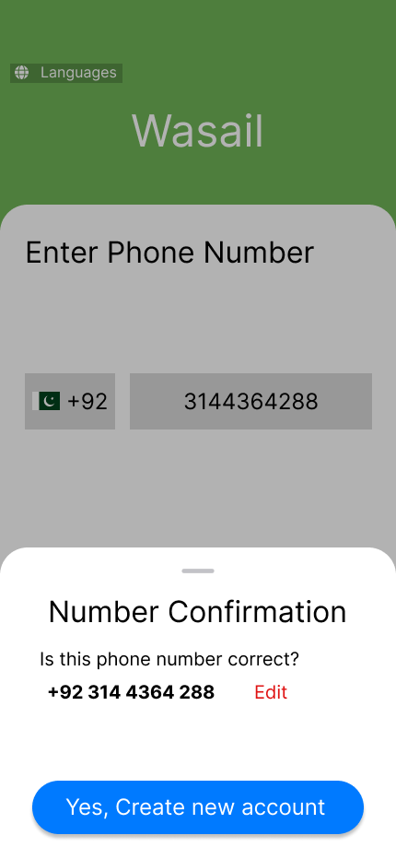

#### **FR1.3:** **Phone Number Confirmation**

* **Description**: The system should allow users to confirm if they entered the number correctly.
* **Actor**: Grocery Store, Vendor
* **Precondition**: The user has entered their phone number.
* **Postcondition**: The user is directed to the one-time password (OTP) screen.
* **Details**:

1. The user is asked to confirm if their phone number has been entered correctly.
2. The system gives the user the option to edit their phone number in case it has not been entered correctly.
3. Upon confirmation, the system should ask the user to create an account.

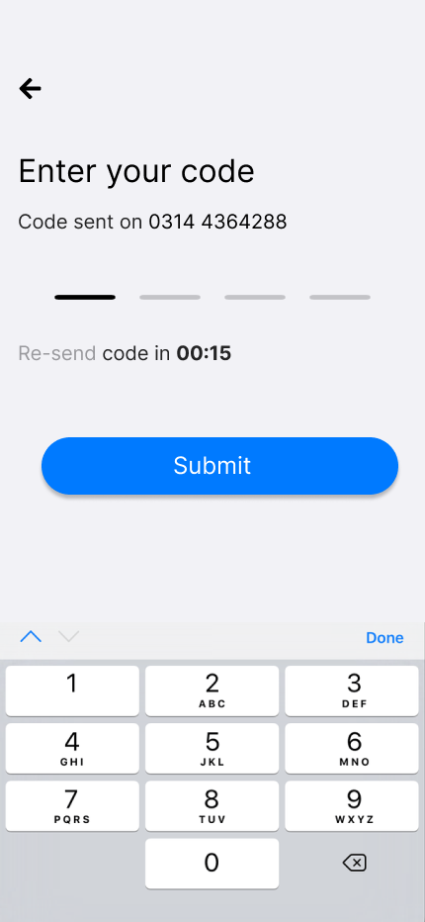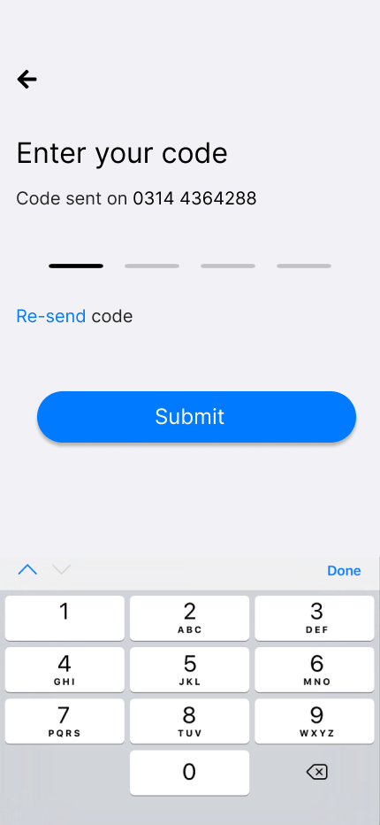

#### **FR1.4:** **OTP Code Generation and Delivery**

* **Description**: The system should send an OTP code to the user’s phone number.
* **Actor**: Grocery Store, Vendor
* **Precondition**: The user has confirmed their phone number.
* **Postcondition**: The user has entered the OTP and is directed to the account details page.
* **Details**:

1. The system generates a 4-digit unique OTP code.
2. The system sends the OTP code to the user's phone number via SMS.
3. The OTP code can be resent after 60 seconds and the timer is being shown to the user.
4. The user is asked to enter the OTP.
5. The system verifies the validity of the OTP code by comparing it to the generated code sent to the given phone number.
6. Upon verification, the user shall be directed to the account details page.

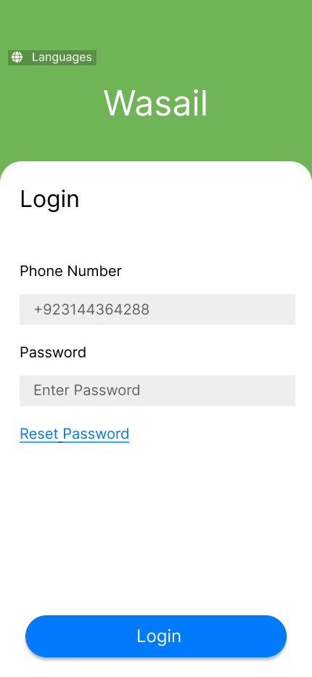

#### **FR1.5:** **Login**

* **Description**:The system should allow the registered users to log in using their credentials.
* **Actor**: Grocery Store, Vendor
* **Precondition**: The user is not logged in.
* **Postcondition**: The user is logged in.
* **Details**:

1. The user is asked to enter their phone number.
2. If the phone number is registered already with the system, the user is asked to enter their password.
3. The system validates the user’s credentials.
4. Upon successful validation, the user is granted access to their profile.

#### **FR1.6:** **Logout**

* **Description**: The system should allow the user to logout
* **Actor**: Grocery Store, Vendor
* **Precondition**: The user is logged in.
* **Postcondition**: The user is logged out.
* **Details**:

1. The system shall give the user the option to log out
2. The user can log out of the system by using the option

#### **FR1.7:** **Reset Password**

* **Description**: The system should allow the user to reset their password
* **Actor**: Grocery Store, Vendor
* **Precondition**: The user is registered.
* **Postcondition**: The user’s password is successfully reset
* **Details**:

1. The system should give the user the option for resetting their password
2. In order to reset their password, the system generates a 4 digit unique OTP code.
3. The system sends the OTP code to the user's phone number via SMS.
4. Upon verification, the user shall enter their new password.
5. The user shall re enter their password for confirmation.
6. After confirmation, the user shall save the password.
7. The system updates the password in the database.

#### **FR1.8:** **View Profile**

* **Description**: The system should allow the user to view their own profile
* **Actor**: Grocery Store, Vendor
* **Precondition**: The user is on their own profile.
* **Postcondition**: The user is able to view their profile.
* **Details**:

1. The system displays the user’s profile.

2. The user can view their profile to see their account details.

### Grocery Store (FR2)

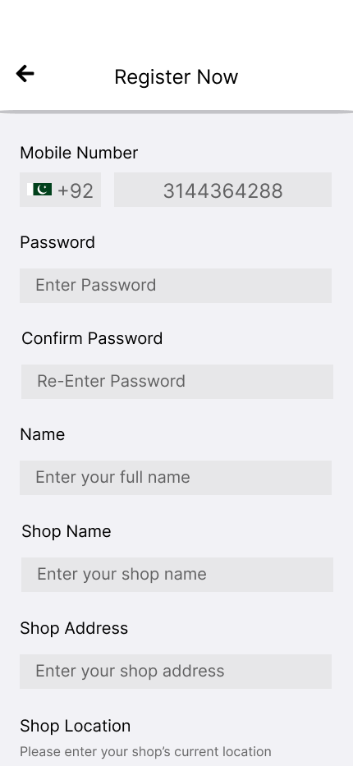

#### **FR2.9:** **Account Details**

* **Description**: The system should allow the user to enter their account details.
* **Actor**: Grocery Store
* **Precondition**: The user has verified their phone number.
* **Postcondition**: The user has registered.
* **Details**:

1. The user enters their account details including their name, store’s name, store’s address, password, and location.
2. User account information is stored in the database.



#### **FR2.10:** **Search Product**

* **Description**: The system should allow the users to search products based on product name and category.
* **Actor**: Grocery Store
* **Precondition**: The user is logged in and on the home page.
* **Postcondition**: The system displays the list of matching products along with the vendors that sell them.
* **Details**:

1. The user can enter the search criteria such as product name or category.
2. The system retrieves and displays the list of matching products along with the vendors that sell them.
3. If no matches are found, the system provides appropriate feedback.

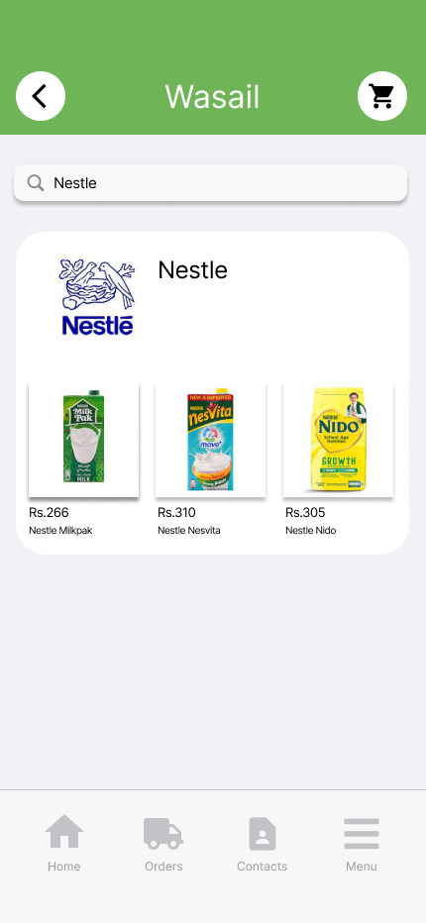

#### **FR2.11:** **Search Vendor**

* **Description**: The system should allow the users to search vendors based on their name.
* **Actor**: Grocery Store
* **Precondition**: The user is logged in and on the home page.
* **Postcondition**: The system displays a list of vendors that deliver in their area based on the search.
* **Details**:

1. The user can enter the search criteria such as vendor name.
2. The system retrieves and displays the vendor along with its popular products.
3. If no matches are found, the system provides appropriate feedback.



#### **FR2.12:** **Browse Category**

* **Description**: The system should allow the user to select a category from the home page directly.
* **Actor**: Grocery Store
* **Precondition**: The user is logged in and on the home page.
* **Postcondition**: The system displays a list of products based on category selection.
* **Details**:

1. The user can select the categories that are being displayed to them.
2. The system retrieves and displays products that fall under the category along with the vendors who sell them.
3. If no match is found, the system provides appropriate feedback.

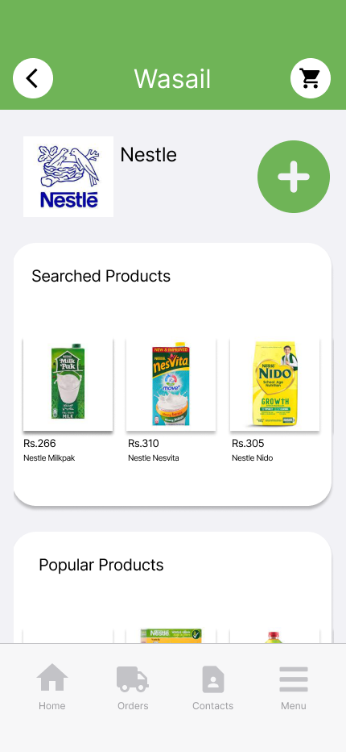

#### **FR2.13:** **View Vendor Profile**

* **Description**: The system should allow the user to view the vendor's profile.
* **Actor**: Grocery Store
* **Precondition**: The user is logged in and has searched the vendor or is on the vendor list page.
* **Postcondition**: The system displays the vendor’s profile.
* **Details**:

1. The user can select the vendor’s profile in order to view it.
2. The system retrieves the vendor’s information including their profile picture, name, product listing, and displays it for the user.

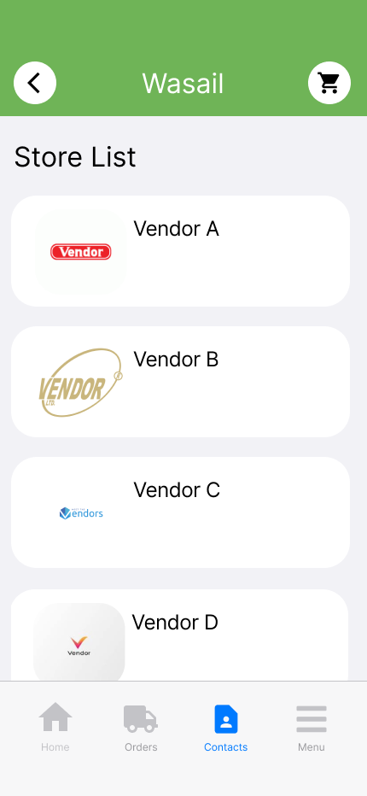

#### FR2.14: Add Vendor to Vendor List

* **Description**: The system should allow the user to add the vendor to their vendor list.
* **Actor**: Grocery Store
* **Precondition**: The user is logged in and on the vendor’s profile.
* **Postcondition**: The vendor is added to the vendor list.
* **Details**:

1. The user can select the option to add the vendor.
2. The vendor is added to the vendors list of the user.

#### **FR2.15:** **Contact Vendor**

* **Description**: The system should allow the user to contact the vendor.
* **Actor**: Grocery Store
* **Precondition**: The user is logged in and on the vendor’s profile.
* **Postcondition**: The user has contacted the vendor.
* **Details**:

1. The system displays the vendor's phone number on the profile.
2. The user can contact the vendor via message or phone call.

#### **FR2.16:** **View Products on the Vendor’s** Profile

* **Description**: The system should allow the user to view all the products that the vendors sell on their profile.
* **Actor**: Grocery Store
* **Precondition**: The user is logged in and on the vendor’s profile.
* **Postcondition**: The user has viewed all the products.
* **Details**:

1. The system retrieves all the products that the vendor sells and displays it to the user.
2. The user can view the products and scroll through them.

#### FR2.17: View Searched Product

* **Description**: The system should allow the user to view the searched product on the vendor's profile.
* **Actor**: Grocery Store
* **Precondition**: The user has searched the product and is on the vendor’s profile.
* **Postcondition**: The user has viewed the searched product on the vendor's profile.
* **Details**:

1. The system displays the searched product on the vendor’s profile.
2. The user can view the products along with their prices and scroll through them.

#### FR2.18: Select Products

* **Description**: The system should allow the user to select the product that they want to order.
* **Actor**: Grocery Store
* **Precondition**: The user is logged in and on the vendor’s profile.
* **Postcondition**: The user is directed to the order placement page.
* **Details**:

1. The system should display products on the vendor’s profile.
2. The user can select from the product list that is being displayed so they can order it.
3. The user can proceed to place the order.



#### FR2.19: Order Recommendation

**Description**: The system should allow the user to view the recommended amount to order.

* **Actor**: Grocery Store
* **Precondition**: The user is logged in and has selected the product.
* **Postcondition**: The user is given a recommendation for the amount of product to order.
* **Details**:

1. After product selection, the user is recommended an amount to order.
2. To generate recommendations, the ML model will be provided with real-time data - product name, price, date, and store’s location from the system and then holiday, exchange rate, and weather through APIs (such as [Open Weather API](https://openweathermap.org/api)).



#### FR2.20: Quantity Selection

* **Description**: The system should allow the user to add their own amount to order.
* **Actor**: Grocery Store
* **Precondition**: The user is logged in and has selected the product.
* **Postcondition**: The user has entered the quantity of the product.
* **Details**:

1. The user is given the option to enter the amount of product they want to order.
2. The user enters the amount of product.
3. The user adds the product to the cart.

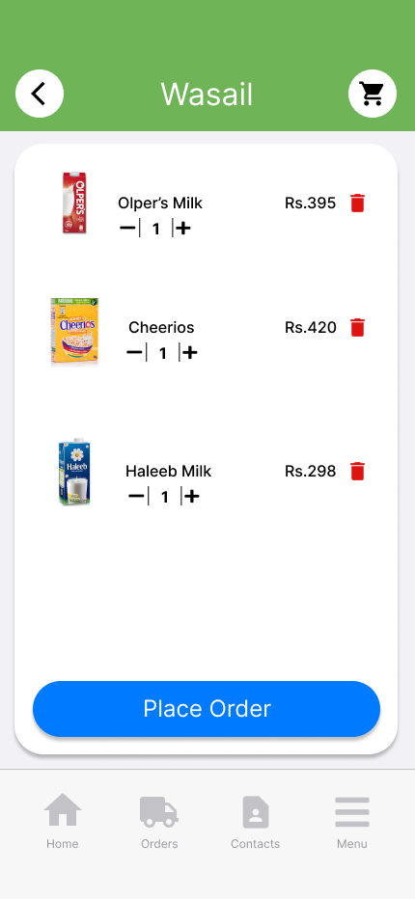

#### **FR2.21:** **Remove Product**

* **Description**: The system should allow the user to remove the product.
* **Actor**: Grocery Store
* **Precondition**: The product is added to the cart.
* **Postcondition**: The product is removed from the cart.
* **Details**:

1. The system gives the option to the user to remove the product from the cart.
2. The user removes the product they do not want to order from the cart.
3. The system stops displaying that product in their cart.



#### **FR2.22:** **Order Placement**

* **Description**: The system should allow the user to place the order.
* **Actor**: Grocery Store
* **Precondition**: The product is added to the cart.
* **Postcondition**: The order is placed.
* **Details**:

1. After the user has added the products to their cart, the system gives the option to place the order.
2. The order is placed to the vendor.
3. The vendor is notified.
4. The order is stored in the database.

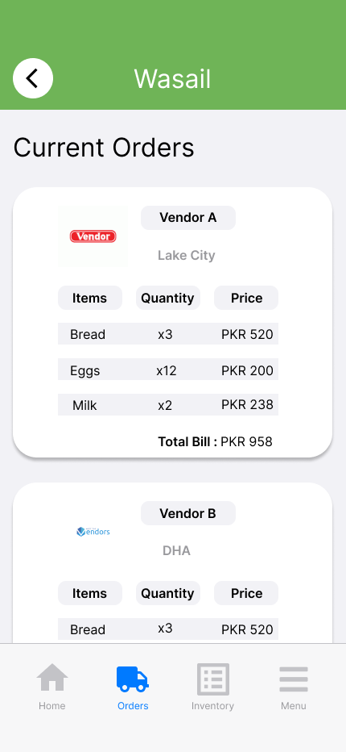

#### **FR2.23:** **View Order**

* **Description**: The system should allow the users to view the current orders that they have placed.
* **Actor**: Grocery Store
* **Precondition**: The user is on the orders page.
* **Postcondition**: The user has viewed the orders that they have placed.
* **Details**:

1. The system should display the orders that the user has placed.
2. The user can view their orders.

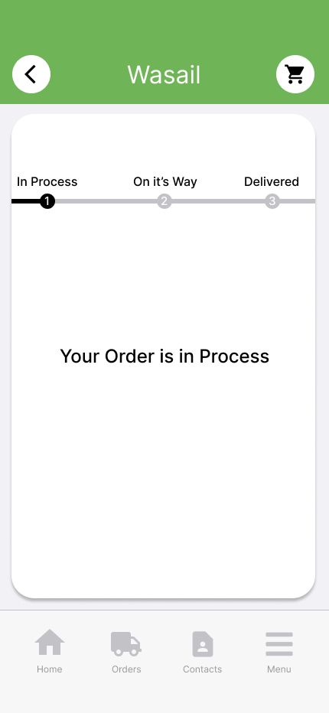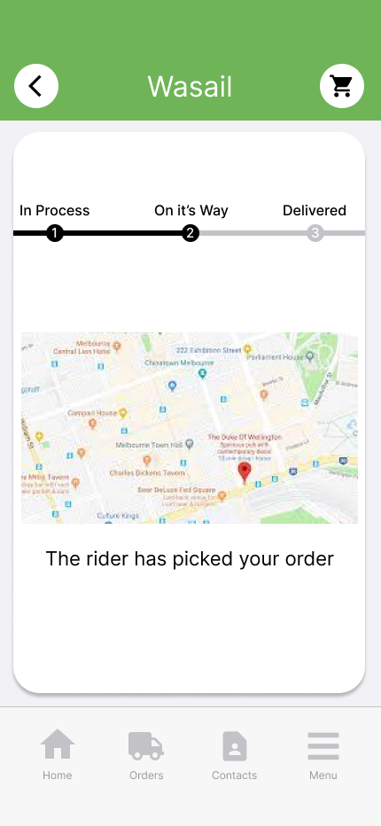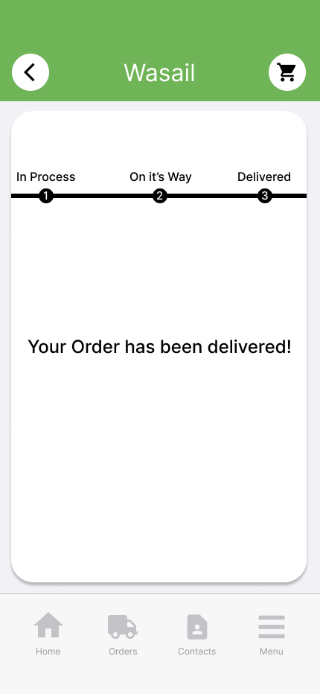

#### **FR2.24:** **Order Tracking**

* **Description**: The system should allow the user to track the order
* **Actor**: Grocery Store
* **Precondition**: The user is on the orders page.
* **Postcondition**: The user is able to track orders.
* **Details**:

1. The system displays all the orders that are placed by the user.
2. The user can select the order which they want to track.
3. Upon order selection, the user can see which process the order is in. The three options are in process, on its way, and delivered.
4. The system notifies the user when the order is delivered
5. The order is marked as delivered in the system

#### **FR2.25:** **View Order History**

* **Description**: The system should allow the user to view their previous orders.
* **Actor**: Grocery Store
* **Precondition**: The user is on the orders history page.
* **Postcondition**: The user is able to view their previous orders.
* **Details**:

1. The system displays all the previous orders the user has placed.
2. The user can view all their previous orders.

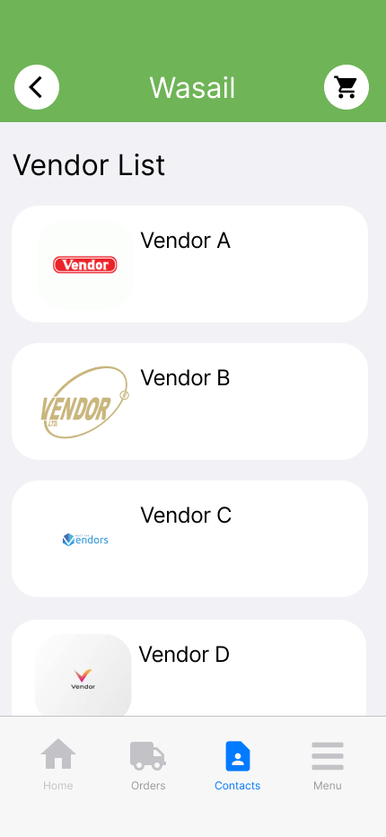

#### **FR2.26:** **View Vendor List**

* **Description**: The system should allow the user to view the vendors in the vendor list
* **Actor**: Grocery Store
* **Precondition**: The user is on the vendor page.
* **Postcondition**: The user is able to view the vendors that they have added.
* **Details**:

1. The system displays all the vendors that the user has added.
2. The user can view the vendors in the vendors list.

#### **FR2.27:** **Edit Profile**

* **Description**: The system should allow the user to edit their profile details
* **Actor**: Grocery Store
* **Precondition**: The user is on their own profile.
* **Postcondition**: The user’s profile is edited.
* **Details**:

1. The system displays the profile to the user.
2. The user can edit the account details that include name, store name, address.
3. The system updates the information in the database.

#### **FR2.28:** **Notification**

* **Description**: The system should provide notification for important events
* **Actor**: Grocery Store
* **Precondition**: The user is logged in.
* **Postcondition**: The user receives notifications for relevant events
* **Details**:

1. User receives notification for order being processed, when the order is on its way to be delivered and when the order has been delivered

### Vendor (FR3)

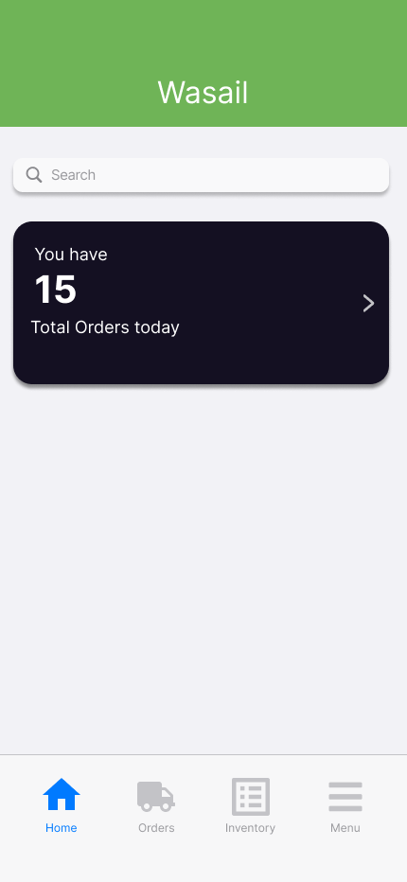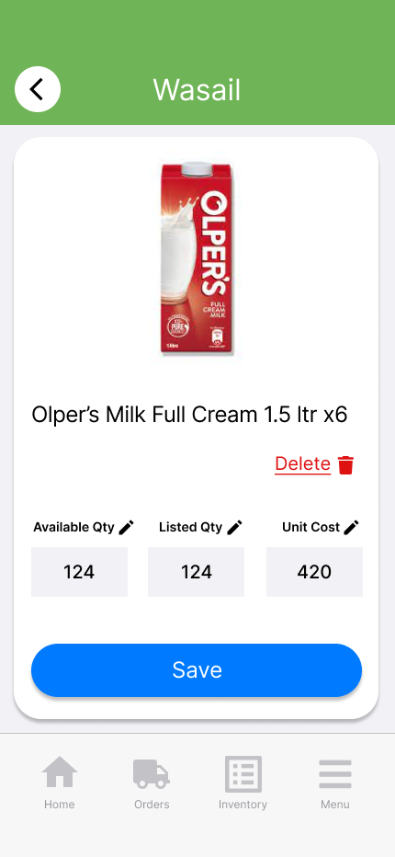

#### FR3.9: Search Product in Inventory

* **Description**: The system should allow the user to search for a product from their inventory.
* **Actor**: Vendor
* **Precondition**: The user is logged in and on the home page.
* **Postcondition**: The system retrieves the matching product’s page.
* **Details**:

1. The user can enter the search criteria namely product name.
2. The system retrieves the matching product’s page.
3. If no matches are found, the system provides appropriate feedback.

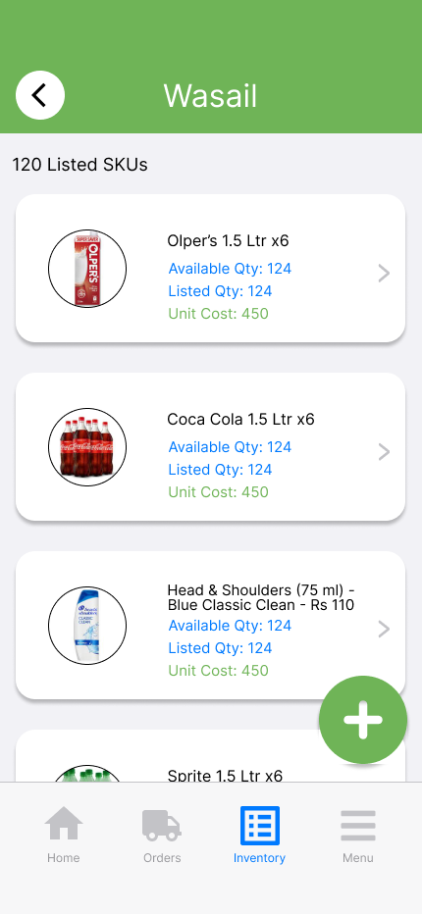

#### FR3.10: Add Product to Inventory

* **Description**: The system should allow the user to add a new product to their inventory.
* **Actor**: Vendor
* **Precondition**: The user is logged in and on the inventory page.
* **Postcondition**: The system has directed the user to the all products search page.
* **Detail**

1. The user wants to add a new product to their inventory.
2. The system gives the user an option to add a new product.
3. The user selects the option to add a new product to the inventory.

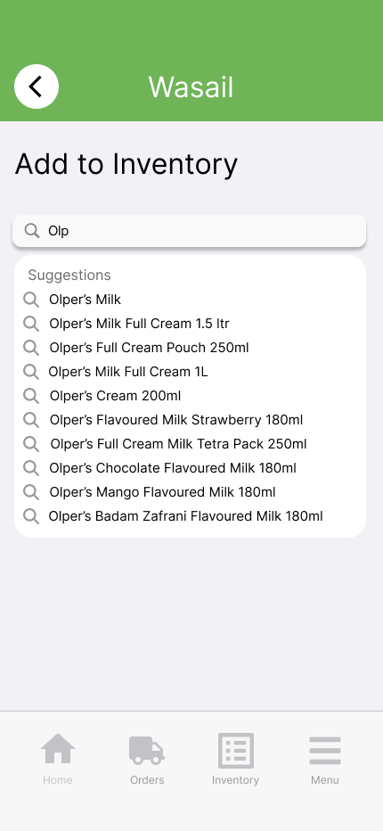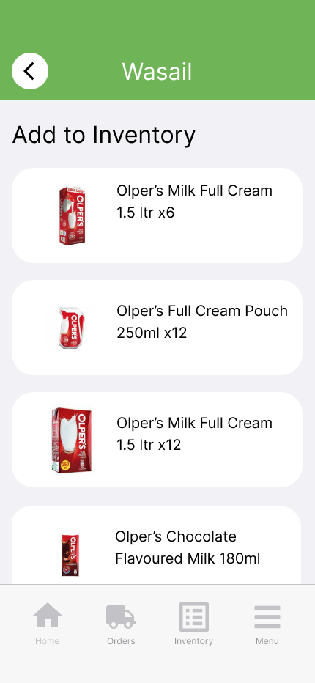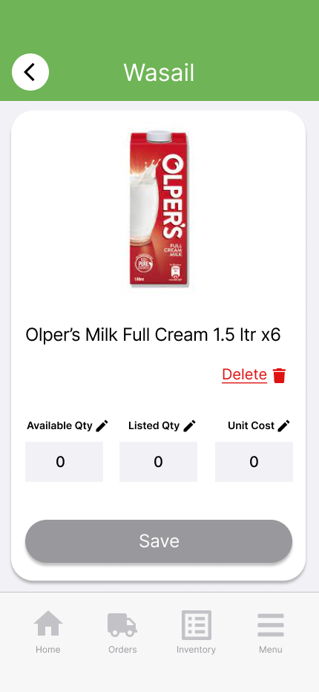

#### FR3.11: All Products Search

* **Description**: The system should allow the user to search all products from the system’s product listing.
* **Actor**: Vendor
* **Precondition**: The user is on the all products search page.
* **Postcondition**: The product is added to their inventory.
* **Details**:

1. The user searches for an item from among all products.
2. The system is prompted to generate a list of item suggestions.
3. The user selects an item from the suggestions.
4. The item is added to the inventory list.
5. The user is redirected to update details of the selected item namely its listed quantity, available quantity, and unit cost.



#### FR3.12: Remove Product

* **Description**: The system should allow the user to remove a product from the inventory.
* **Actor**: Vendor
* **Precondition**: The user is on the product’s page.
* **Postcondition**: The product has been removed from their inventory.
* **Details**:

1. The system gives the option to the user to remove the product from the inventory.
2. The user removes the product they do not want to keep in the inventory.
3. The system stops displaying that product in the inventory.



#### FR3.13: Edit Details of Product

* **Description**: The system should allow the user to edit the details of products already in their inventory.
* **Actor**: Vendor
* **Precondition**: The user has added the product to their inventory
* **Postcondition**: The details of the product have been edited.
* **Details**:

1. The system displays the product page for the user.
2. The system gives the user the option to edit the product details.
3. The user edits the product details namely its listed quantity, available quantity, and unit cost.
4. The system will save the edited product details.



#### FR3.14: View Inventory

* **Description**: The system should allow the user to view their inventory (product listings)
* **Actor**: Vendor
* **Precondition**: The user is logged in and on the inventory page.
* **Postcondition**: The user is able to view the inventory.
* **Details**:

1. The system should display the inventory of the user.
2. The user can view their inventory.

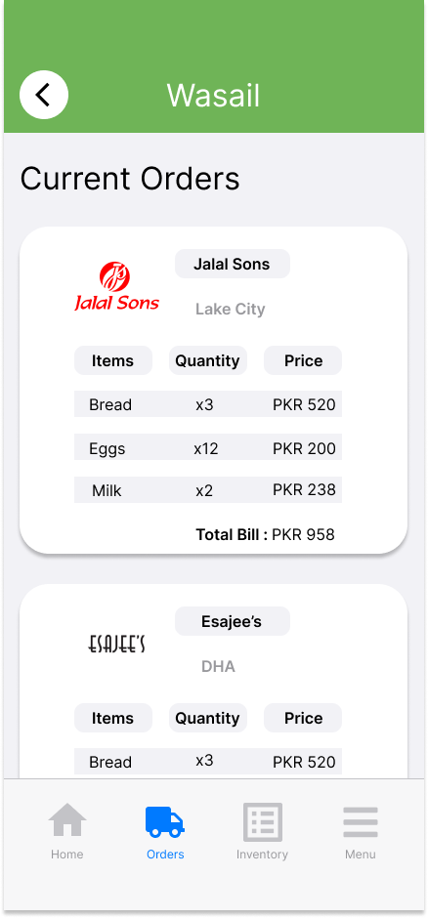

#### FR3.15: View Current Orders

* **Description**: The system should allow the user to view the total number of current orders from all grocery stores.
* **Actor**: Vendor
* **Precondition**: The user is logged in and on the orders page.
* **Postcondition**: The user can view all the orders received.
* **Details**:

1. The system displays all the orders that the user has received and has to deliver.
2. The user can view all the orders.

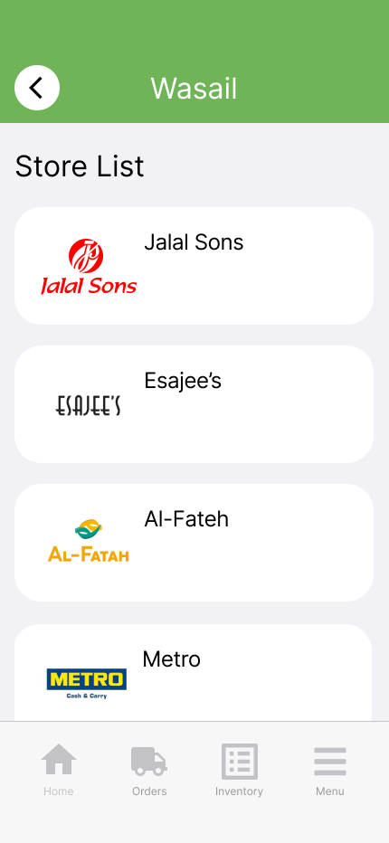

#### FR3.16: View Grocery Stores List

* **Description**: The system should allow the user to view the grocery store list.
* **Actor**: Vendor
* **Precondition**: The user is logged in and on the store list page.
* **Postcondition**: The user is able to view the list of grocery stores that placed orders.
* **Details**:

1. The system displays all the grocery stores that have placed orders.
2. The user can view the grocery stores in the stores list.

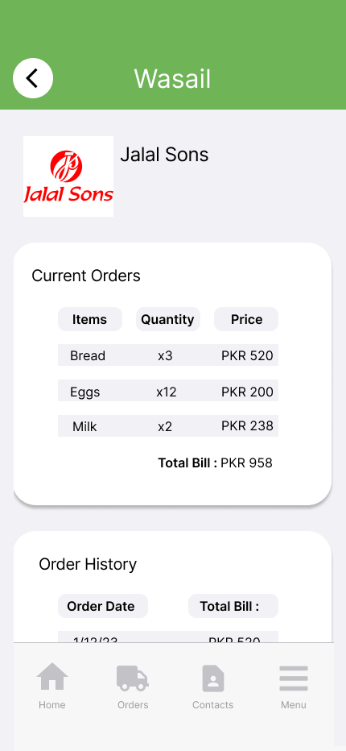

#### FR3.17: View Grocery Store Profile

* **Description**: The system should allow the user to view the grocery store profile
* **Actor**: Vendor
* **Precondition**: The user is on the store list page
* **Postcondition**: The system displays the grocery store’s profile.
* **Details**:

1. The user can select the grocery store’s profile to view it.
2. The system retrieves the grocery store’s information including their profile picture, name, and area in which they are, and displays it for the user.



#### FR3.18: View Grocery Store Current Order

* **Description**: The system should allow the user to view the current order placed by the grocery store (profile)
* **Actor**: Vendor
* **Precondition**: The user is on the grocery store’s profile page.
* **Postcondition**: The user has viewed the current order that they have received from the grocery store.
* **Details**:

1. The system should display the current orders that the user has received from the grocery store.
2. The user can view their current orders received.



#### FR3.19: View Orders History

* **Description**: The system should allow the user to view the orders they have already completed delivering.
* **Actor**: Vendor
* **Precondition**: The user is on the orders history page.
* **Postcondition**: The user is able to view the delivered orders.
* **Details**:

1. The system displays all the orders the user has delivered.
2. The user can view all their delivered orders.

#### FR3.20: Edit Profile

* **Description**: The system should allow the user to edit their profile details
* **Actor**: Vendor
* **Precondition**: The user is on their own profile.
* **Postcondition**: The user’s profile is edited.
* **Details**:

1. The system displays the profile to the user
2. The user can edit the account details including name, store name, and address.
3. The system updates the information in the database

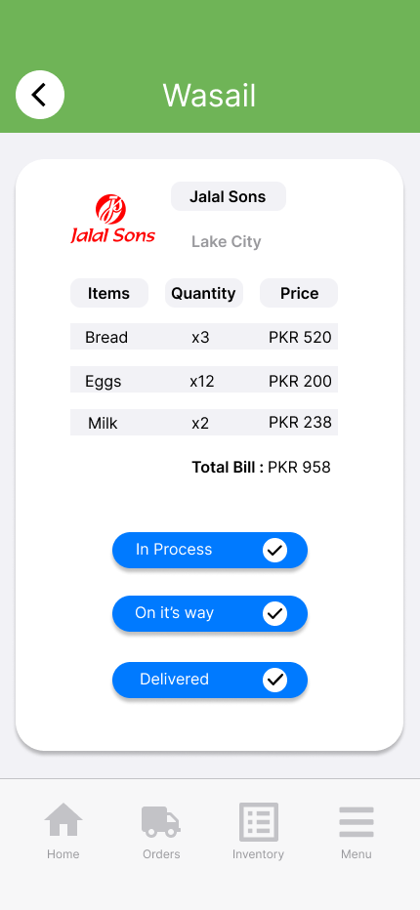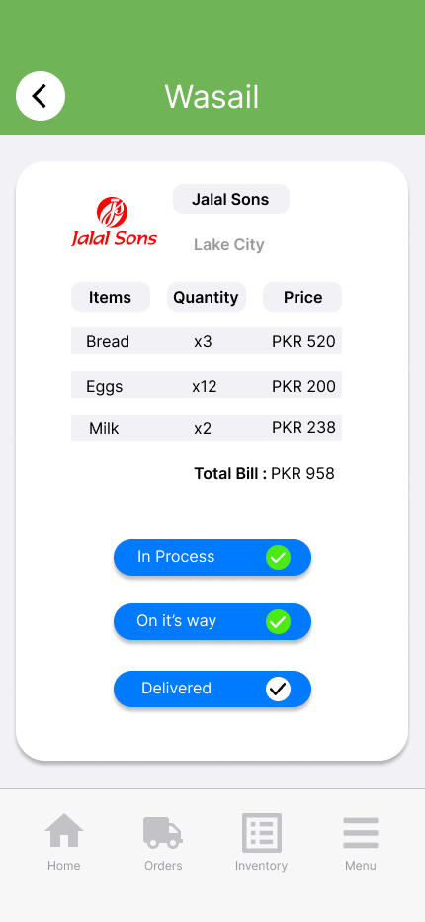

#### FR3.21: Order Dispatch Tracking

* **Description**: The system should allow the user to track the dispatched order.
* **Actor**: Vendor
* **Precondition**: The user is on the orders page.
* **Postcondition**: The user is able to track order dispatches.
* **Details**:

1. The system displays all the orders that are dispatched by the user.
2. The user can select the order in which they want to track dispatch progress.
3. Upon order selection, the user can update which process the order is in. The three options are in process, on their way, and delivered.
4. The user updates the system on the progress of order delivery.
5. The user successfully completes the delivery and updates the system.
6. The system notifies of completed delivery.

#### FR3.22: Restrict Product Duplication

* **Description**: The system should restrict duplication of products.
* **Actor**: Vendor
* **Precondition**: The user is attempting to add an already existing product to their inventory.
* **Postcondition**: The system prevents the addition of duplicate products and alerts the user.
* **Details**:

1. The user tries to add a product with the same name or category as an existing product in their inventory.
2. The system will alert the user that the product already exists in their inventory and instead offer to update the existing product.
3. The system does not allow duplication of an already existing product within the inventory.

## Non-Functional Requirements

* **Performance:**

1. **Scalability**: The system should be able to handle a growing number of users, both grocery stores and vendors, without a significant decrease in performance.

* **Security:**.

1. **Access Control**: Role-based access control should be in place to restrict unauthorised access to sensitive functionalities and data.

* **Usability:**

1. **Multilingual Support**: The system should support multiple languages (English, Roman Urdu, Urdu) as per FR1.1 to cater to a diverse user base.
2. **User-Friendly Interface**: The user interface should be intuitive and easy to use, ensuring a seamless experience for both grocery stores and vendors.

* **Data Storage:**

1. **Data Capacity**: The system should be capable of handling a large volume of user data, product listings, and order history efficiently.

* **Notification System:**

1. **Real-Time Notifications**: The notification system should deliver real-time updates on orders, deliveries, and important events to users.

* **Error Handling:**

1. **Error Messages**: Clear and informative error messages should be provided to assist users in troubleshooting issues.

* **Reporting and Logging:**

1. **Activity Logging**: The system should maintain logs of user activities, including login attempts, order changes, and product updates, to facilitate auditing and troubleshooting.

* **Integration:**

1. **Third-Party Integrations**: The system should seamlessly integrate with SMS services for OTP delivery, and other third-party services as required.

* **Mobile Responsiveness:**

1. **Cross-Platform Compatibility**: The system should be accessible and user-friendly on various mobile devices.

# Test Cases

**Test Case 1: Language Selection (FR1.1)**

* **Test Scenario**: The user wants to select their preferred language.
* **Preconditions**: The user has not specified their preferred language.
* **Test Steps**:

1. Open the app.
2. Navigate to the language selection option.
3. Select English as the preferred language.

* **Expected Result**: The app's text is displayed in English. The selected language is stored in the database.
* **Alternate Flow 1**: User selects Roman Urdu as the preferred language.
* **Expected Result**: The app's text is displayed in Roman Urdu. The selected language is stored in the database.
* **Alternate Flow 2**: User selects Urdu as the preferred language.
* **Expected Result**: The app's text is displayed in Urdu. The selected language is stored in the database.

**Test Case 2: Phone Registration (FR1.2)**

* **Test Scenario:** The user wants to create an account using their phone number.
* **Preconditions:** The user is not registered in the system.
* **Test Steps:**

1. Open the app.
2. Navigate to the phone registration option.
3. Enter a valid phone number.
4. Tap the "Register" button.

* **Expected Result:** The user is directed to the phone number confirmation screen. The system validates the phone number format.
* **Alternate Flow 1:** User enters an invalid phone number.
* **Expected Result:** The system displays an error message indicating that the phone number format is incorrect and prompts the user to enter a valid phone number.

**Test Case 3: Phone Number Confirmation (FR1.3)**

* **Test Scenario:** The user wants to confirm their entered phone number.
* **Preconditions:** The user has entered their phone number.
* **Test Steps:**

1. Enter the phone number confirmation screen.
2. Confirm if the entered phone number is correct.
3. If incorrect, edit the phone number.
4. Upon confirmation, the system asks the user to create an account

* **Expected Result:** The user is directed to the OTP screen if the phone number is confirmed.

**Test Case 4: OTP Code Generation and Delivery (FR1.4)**

* Test Scenario: The user receives an OTP code for phone number verification.
* Preconditions: The user has confirmed their phone number.
* Test Steps:

1. The system generates a 4-digit unique OTP code.
2. Sends the OTP code to the user's phone number via SMS.
3. User is asked to enter the OTP.
4. The system verifies the validity of the OTP code.

* Expected Result: The user is directed to the account details page upon successful verification.
* Alternate Flow 1: User enters an incorrect OTP code.
* Expected Result: The system displays an error message indicating that the OTP code is incorrect and prompts the user to re-enter it.

**Test Case 5: Login (FR1.5)**

* **Test Scenario:** Registered users want to log in using their credentials.
* **Preconditions:** The user is not logged in.
* **Test Steps:**

1. Enter the phone number.
2. If the phone number is registered, enter the password.
3. The system validates the user's credentials.

* **Expected Result:** Upon successful validation, the user is granted access to their profile.
* **Alternate Flow 1:** User enters an incorrect phone number.
* Expected Result: The system displays an error message indicating that the phone number is not registered.
* **Alternate Flow 2:** User enters an incorrect password.
* **Expected Result:** The system displays an error message indicating that the password is incorrect.

**Test Case 6: Logout (FR1.6)**

* **Test Scenario:** The user wants to log out of the system.
* **Preconditions:** The user is logged in.
* **Test Steps:**

1. The system gives the user the option to log out.
2. The user logs out of the system using the option.

* **Expected Result:** The user is logged out of the system.

**Test Case 7: Reset Password (FR1.7)**

* **Test Scenario:** The user wants to reset their password.
* **Preconditions:** The user is registered.
* **Test Steps:**

1. The system gives the user the option to reset their password.
2. The system generates a 4-digit unique OTP code.
3. Sends the OTP code to the user's phone number via SMS.
4. Upon verification, the user enters their new password.
5. The user re-enters their password for confirmation.
6. After confirmation, the user saves the password.

* **Expected Result:** The user's password is successfully reset, and the system updates it in the database.

**Test Case 8: View Profile (FR1.8)**

* **Test Scenario**: The user wants to view their own profile.
* **Preconditions**: The user is on their own profile.
* **Test Steps**:

1. The system displays the user's profile.
2. The user can view their account details.

* **Expected Result:** The user is able to view their profile.

**Test Case 9: Account Details (FR2.9)**

* **Test Scenario**: The user wants to enter their account details.
* **Preconditions**: The user has verified their phone number.
* **Test Steps**:

1. The user enters their account details, including their name, store’s name, store’s address, password, and location.
2. User account information is securely stored in the database.

* Expected Result: The user's account details are successfully saved in the database.

**Test Case 10: Search Product (FR2.10)**

* **Test Scenario**: The user wants to search for products based on product name and category.
* **Preconditions**: The user is logged in and on the home page.
* **Test Steps**:

1. The user enters search criteria, such as a product name or category.
2. The system retrieves and displays the list of matching products along with the vendors that sell them.

* **Expected Result**: The user sees a list of matching products and vendors. If no matches are found, the system provides appropriate feedback.

**Test Case 11: Search Vendor (FR2.11)**

* **Test Scenario**: The user wants to search vendors based on their name.
* **Preconditions**: The user is logged in and on the home page.
* **Test Steps**:

1. The user enters the search criteria, such as a vendor name.
2. The system retrieves and displays the vendor along with its popular products.

* **Expected Result**: The user sees a list of vendors that deliver in their area based on the search. If no matches are found, the system provides appropriate feedback.

**Test Case 12: Browse Category (FR2.12)**

* **Test Scenario**: The user wants to select a category from the home page directly.
* **Preconditions**: The user is logged in and on the home page.
* **Test Steps**:

1. The user selects the categories that are being displayed to them.
2. The system retrieves and displays products that fall under the category along with the vendors who sell them.

* **Expected Result**: The user views products and vendors based on the selected category. If no match is found, the system provides appropriate feedback.

**Test Case 13: View Vendor Profile (FR2.13)**

* **Test Scenario**: The user wants to view the vendor's profile.
* **Preconditions**: The user is logged in and has searched the vendor or is on the vendor list page.
* **Test Steps**:

1. The user selects the vendor’s profile to view it.
2. The system retrieves the vendor’s information, including their profile picture, name, area in which they deliver, and displays it for the user.

* **Expected Result**: The user is able to view the vendor's profile.

**Test Case 14: Add Vendor to Vendor List (FR2.14)**

* **Test Scenario:** The user wants to add the vendor to their vendor list.
* **Preconditions**: The user is logged in and on the vendor’s profile.
* **Test Steps**:

1. The user selects the option to add the vendor.
2. The vendor is added to the vendors list of the user.

* **Expected Result**: The vendor is successfully added to the user's vendor list.

**Test Case 15: Contact Vendor (FR2.15)**

* **Test Scenario**: The user wants to contact the vendor.
* **Preconditions**: The user is logged in and on the vendor’s profile.
* **Test Steps**:

1. The system displays the vendor's phone number on the profile.
2. The user can contact the vendor via message or phone call.

* **Expected Result**: The user successfully contacts the vendor through the provided contact information.

**Test Case 16: View Products on the Vendor’s Profile (FR2.16)**

* **Test Scenario**: The user wants to view all the products that the vendor sells on their profile.
* **Preconditions**: The user is logged in and on the vendor’s profile.
* **Test Steps**:

1. The system retrieves all the products that the vendor sells and displays them to the user.
2. The user can view the products and scroll through them.

* **Expected Result**: The user can view all the products offered by the vendor on their profile.

**Test Case 17: View Searched Product (FR2.17)**

* **Test Scenario**: The user wants to view the searched product on the vendor's profile.
* **Preconditions**: The user has searched for a product and is on the vendor’s profile.
* **Test Steps**:

1. The system displays the searched product on the vendor’s profile.
2. The user can view the products along with their prices and scroll through them.

* **Expected Result**: The user can view the searched product on the vendor's profile, including prices and details.

**Test Case 18: Select Products (FR2.18)**

* **Test Scenario**: The user wants to select the product they want to order.
* **Preconditions**: The user is logged in and on the vendor’s profile.
* **Test Steps**:

1. The system displays products on the vendor’s profile.
2. The user can select products from the product list to order them.
3. The user can proceed to place the order.

* **Expected Result**: The user successfully selects products and proceeds to place an order.

**Test Case 19: Order Recommendation (FR2.19)**

* **Test Scenario**: The user wants to view the recommended amount to order.
* **Preconditions**: The user has selected a product.
* **Test Steps**:

1. After product selection, the user is recommended an amount to order.
2. The recommendation is based on..

* **Expected Result**: The user receives a recommendation for the amount of the selected product.

**Test Case 20: Quantity Selection (FR2.20)**

* **Test Scenario**: The user wants to add their own quantity to order.
* **Preconditions**: The user is logged in and has selected a product.
* **Test Steps**:

1. The user is given the option to enter the amount of the product they want to order.
2. The user enters the desired quantity.
3. The user adds the product to the cart.

* **Expected Result**: The user successfully enters the quantity and adds the product to the cart.

**Test Case 21: Remove Product (FR2.21)**

* **Test Scenario**: The user wants to remove a product from the cart.
* **Preconditions**: The product is added to the cart.
* **Test Steps**:

1. The system gives the option to the user to remove the product from the cart.
2. The user removes the product they do not want to order from the cart.
3. The system stops displaying that product in their cart.

* **Expected Result**: The user successfully removes the product from the cart.

**Test Case 22: Order Placement (FR2.22)**

* **Test Scenario**: The user wants to place an order.
* **Preconditions**: The product is added to the cart.
* **Test Steps**:

1. After the user has added the products to their cart, the system gives the option to place the order.
2. The order is placed to the vendor.
3. The vendor is notified.
4. The order is stored in the database.

* **Expected Result**: The order is successfully placed, and the vendor is notified.

**Test Case 23: View Order (FR2.23)**

* **Test Scenario**: The user wants to view the current orders they have placed.
* **Preconditions**: The user is on the orders page.
* **Test Steps**:

1. The system should display the orders that the user has placed.
2. The user can view their orders.

* **Expected Result**: The user can view their current orders.

**Test Case 24: Order Tracking (FR2.24)**

* **Test Scenario**: The user wants to track the order.
* **Preconditions**: The user is on the orders page.
* **Test Steps**:

1. The system displays all the orders that are placed by the user.
2. The user can select the order they want to track.
3. Upon order selection, the user can see which process the order is in: in process, on its way, or delivered.
4. The system notifies the user when the order is delivered.
5. The order is marked as delivered in the system.

* **Expected Result**: The user can track the progress of their order and receive notifications for the order's status.

**Test Case 25: View Order History (FR2.25)**

* **Test Scenario**: The user wants to view their previous orders.
* **Preconditions**: The user is on the orders history page.
* **Test Steps**:

1. The system displays all the previous orders the user has placed.
2. The user can view all their previous orders.

* **Expected Result**: The user can view their order history.

**Test Case 26: View Vendor List (FR2.26)**

* **Test Scenario**: The user wants to view the vendors in the vendor list.
* **Preconditions**: The user is on the vendor page.
* **Test Steps**:

1. The system displays all the vendors that the user has added.
2. The user can view the vendors in the vendor list.

* **Expected Result**: The user can view the vendors they have added to their list.

**Test Case 27: Edit Profile (FR2.27)**

* **Test Scenario**: The user wants to edit their profile details.
* **Preconditions**: The user is on their own profile.
* **Test Steps**:

1. The system displays the profile to the user.
2. The user can edit the account details, including name, store name, and address.
3. The system updates the information in the database.

* **Expected Result**: The user's profile details are successfully edited and updated in the database.

**Test Case 28: Notification (FR2.28)**

* **Test Scenario**: The user wants to receive notifications for important events.
* **Preconditions**: The user is logged in.
* **Test Steps**:

1. The user receives notifications for the order being processed, when the order is on its way to be delivered, and when the order has been delivered.

* **Expected Result**: The user receives timely notifications for relevant events.

**Test Case 29: Search Product in Inventory (FR3.9)**

* **Test Scenario**: The vendor wants to search for a product in their inventory.
* **Preconditions**: The vendor is logged in and has products in their inventory.
* **Test Steps**:

1. Open the app.
2. Go to the "Inventory" section.
3. Enter search criteria, such as product name or category.
4. Tap the "Search" button.

* **Expected Result**: A list of matching products in the vendor's inventory is displayed, sorted by relevance.

**Test Case 30: Add Product to Inventory (FR3.10)**

* **Test Scenario**: The vendor wants to add a new product to their inventory.
* **Preconditions**: The vendor is logged in and on the inventory page.
* **Test Steps**:

1. In the "Inventory" section, select the option to add a new product.
2. Enter the details of the new product, including name, category, quantity, and unit cost.
3. Confirm the addition of the product to the inventory.

* Expected Result: The new product is successfully added to the vendor's inventory.

**Test Case 31: Remove Product (FR3.12)**

* **Test Scenario:** The vendor wants to remove a product from their inventory.
* **Preconditions:** The vendor is on the product's page.
* **Test Steps:**

1. The system gives the option to the vendor to remove the product from their inventory.
2. The vendor removes the product they no longer want in the inventory.
3. The system stops displaying that product in their inventory.

**Expected Result:** The vendor successfully removes the product from their inventory.

**Test Case 32: Edit Details of Product (FR3.13)**

* **Test Scenario:** The vendor wants to edit the details of a product in their inventory.
* **Preconditions:** The vendor has added the product to their inventory.
* **Test Steps:**

1. The system displays the product page for the vendor.
2. The system gives the vendor the option to edit the product details, including listed quantity, available quantity, and unit cost.
3. The vendor edits the product details.
4. The system saves the edited product details.

* **Expected Result:** The product details in the inventory are successfully edited.

**Test Case 33: View Inventory (FR3.14)**

* **Test Scenario**: The vendor wants to view their inventory (product listings).
* **Preconditions**: The vendor is logged in.
* **Test Steps**:

1. The vendor goes to the "Inventory" section.
2. The system should display the inventory of the vendor.
3. The vendor can view their inventory.

* **Expected Result**: The vendor can view their product listings in the inventory.

**Test Case 34: View Current Orders (FR3.15)**

* **Test Scenario**: The vendor wants to view the total number of current orders from all grocery stores.
* **Preconditions**: The vendor is logged in and has pending orders.
* **Test Steps**:

1. The vendor goes to the "Orders" section.
2. The system displays all the current orders that the vendor has received and needs to deliver.
3. The vendor can view all the current orders.

* **Expected Result**: The vendor can view the list of current orders they need to fulfil.

**Test Case 35: View Grocery Stores List (FR3.16)**

* **Test Scenario**: The vendor wants to view the grocery store list.
* **Preconditions**: The vendor is logged in.
* **Test Steps**:

1. The vendor goes to the "Stores List" section.
2. The system displays a list of grocery stores that have placed orders with the vendor.
3. The vendor can view the grocery stores in the list.

* **Expected Result**: The vendor can view the list of grocery stores that have placed orders.

**Test Case 36: View Grocery Store Profile (FR3.17)**

* **Test Scenario**: The vendor wants to view the profile of a specific grocery store.
* **Preconditions**: The vendor is on the store list page.
* **Test Steps**:

1. The vendor selects a grocery store's profile to view.
2. The system retrieves the grocery store's information, including their profile picture, name, and delivery area.
3. The information is displayed for the vendor.

* **Expected Result**: The vendor can view the selected grocery store's profile.

**Test Case 37: View Grocery Store Current Order (FR3.18)**

* **Test Scenario**: The vendor wants to view the current order placed by a specific grocery store.
* **Preconditions**: The vendor is on the grocery store's profile page.
* **Test Steps**:

1. The vendor selects the grocery store's profile.
2. The system should display the current orders that the vendor has received from the grocery store.
3. The vendor can view the current order placed by that grocery store.

* **Expected Result**: The vendor can view the current order details placed by the grocery store.

**Test Case 38: View Orders History (FR3.19)**

* **Test Scenario**: The vendor wants to view their order history, including previously completed deliveries.
* **Preconditions**: The vendor is on the orders history page.
* **Test Steps**:

1. The system displays all the orders the vendor has delivered.
2. The vendor can view all their delivered orders.

* **Expected Result**: The vendor can access and review their order history, including successfully delivered orders.

**Test Case 39: Edit Profile (FR3.20)**

* **Test Scenario**: The vendor wants to edit their profile details.
* **Preconditions**: The vendor is on their own profile.
* **Test Steps**:

1. The system displays the vendor's profile.
2. The vendor can edit the account details, including name, store name, and address.
3. The system updates the information in the database.

* **Expected Result**: The vendor's profile details are successfully edited and updated in the database.

**Test Case 40: Order Dispatch Tracking (FR3.21)**

* **Test Scenario**: The vendor wants to track the progress of order dispatch.
* **Preconditions**: The vendor is on the orders page.
* **Test Steps**:

1. The system displays all the orders that are dispatched by the vendor.
2. The vendor can select the order they want to track the dispatch progress for.
3. The vendor updates the system on the progress of order delivery (in process, on its way, or delivered).
4. The system notifies the vendor of the completed delivery.

* **Expected Result**: The vendor can track the status of order dispatch and receive notifications.

**Test Case 41: Restrict Product Duplication (FR3.22)**

* **Test Scenario**: The vendor tries to add a product that already exists in their inventory.
* **Preconditions**: The vendor is adding a product to their inventory.
* **Test Steps**:

1. The vendor tries to add a product with the same name or category as an existing product in their inventory.

* **Expected Result**: The system should alert the vendor that the product already exists in their inventory and offer to update the existing product. The system should not allow duplication of an existing product.

# Machine Learning Requirements

**1. Objective and Use Case:**

Objective: Provide a recommended amount of product to order for the grocery stores.

Use Case: “As a grocery store, I want to receive a recommended amount of product to order based on my previous sales.”

**2. Data Requirements:**

**Data Sources:**

* Sales
* Holidays
* Weather
* Exchange Rate (USD to PKR) / Fuel Prices

**Data Collection:**

* Grocery Stores
* Vendors (Upload on GitHub)
* Pharmacies (Upload on GitHub)
* Kaggle
  + [Corporación Favorita Grocery Sales Forecasting](https://www.kaggle.com/competitions/favorita-grocery-sales-forecasting)
  + [Instacart Market Basket Analysis](https://www.kaggle.com/competitions/instacart-market-basket-analysis)
  + [Grupo Bimbo Inventory Demand](https://www.kaggle.com/competitions/grupo-bimbo-inventory-demand)
  + [Store Sales - Time Series Forecasting](https://www.kaggle.com/competitions/store-sales-time-series-forecasting)
  + [Store Item Demand Forecasting Challenge](https://www.kaggle.com/competitions/demand-forecasting-kernels-only)

**3. Feature Engineering:**

Input Variables

* Date
* Product Name
* Sales
* Type / Family (Frozen, Bakery etc)
* Holiday
* Location
* Weather
* Exchange Rate / Fuel Prices

**4. ML Model Selection:**

Baseline Models

* Naive Seasonal Model
* Exponential Smoothing
* Facebook Prophet

Deep Learning Models

* LSTM (Long Short-Term Memory)
* N-HiTS (Neural Hierarchical Interpolation for TS Forecasting)
* TFT (Temporal Fusion Transformer)

**5. Model Training and Testing:**

Split

* Stratified Shuffle Split
  + Training Set (80%)
  + Validation Set (20%)

Evaluation Metric

* Root Mean Squared Logarithmic Error (RMSLE)

**6. Integration with User Interface:**

The ML model will generate a recommended amount to order for each product while the grocery store is placing the order. The grocery store will display this recommended amount next to the input field for quantity. The grocery store can either order the recommended amount or enter the amount to order manually.



**7. Recommendation Updates:**

To generate recommendations, the ML model will be provided with real-time data - product name, price, date, and store’s location from the system and then holiday, exchange rate, and weather through APIs (such as [Open Weather API](https://openweathermap.org/api)).

**8. Feedback and Learning:**

The data accumulated through the inventory management module will be used in the next iteration of the training. An increase in data overtime will increase the overall performance of the model as well. However, even though increasing the data is the most influential factor, it is not the only way to improve performance. The LSTM model (1995) has been around for some time, whereas TFT (2019) and N-HiTS (2022) are relatively new models. We shall continue to explore new discoveries in deep learning models, they might be more apt to target our problem.

**9. Performance and Scalability:**

To ensure the performance and scalability of the ML component, the model will be deployed on Google Cloud (or AWS).

**10. Testing and Validation:**

The ML model will be trained and evaluated on a dataset split into an 80:20 ratio for training and validation, respectively, with cross-validation applied during training.

# References

[1][L. X. Lu and J. M. Swaminathan, "Advances in Supply Chain Management," SSRN Electronic Journal, January 2013. DOI: 10.2139/ssrn.2758860.](https://www.researchgate.net/publication/314854642_Advances_in_Supply_Chain_Management)

[2] [H. A. Khawaja, "What are the problems faced by the retail sector in Pakistan?" Online Blog Article, 2021.](https://macropakistani.com/retail-sector-in-pakistan/)

[3] [G. Ondiek, "Inventory management automation and performance of supermarkets in western Kenya," 2015.](https://www.researchgate.net/publication/283620946_Inventory_mangement_automation_and_performance_of_supermarkets_in_western_Kenya)

[4] [A. Sharma, "AI and Robotics for Reducing Waste in the Food Supply Chain: Systematic Literature Review, Theoretical Framework and Research Agenda," 2020.](https://www.google.com/url?sa=t&rct=j&q=&esrc=s&source=web&cd=&ved=2ahUKEwigh6_036KCAxVya_EDHUF2BgUQFnoECBYQAQ&url=https%3A%2F%2Fosf.io%2F68vmj%2Fdownload&usg=AOvVaw068EhNlX98lKfjBCDuPfE0&opi=89978449)

[5] [S. K. Panda and S. N. Mohanty, "Time Series Forecasting and Modeling of Food Demand Supply Chain Based on Regressors Analysis," 2023.](https://ieeexplore.ieee.org/stamp/stamp.jsp?arnumber=10098799)

[6] [Y. Liu, "Grocery Sales Forecasting," 2022.](https://www.atlantis-press.com/proceedings/cike-22/125972906)

[7] [R. A. Carbonneau, R. Vahidov, K. Laframboise, "Machine Learning-Based Demand Forecasting in Supply Chains," 2007.](https://www.researchgate.net/publication/220208887_Machine_Learning-Based_Demand_Forecasting_in_Supply_Chains)

[8] [S. Gull, I. Sarwar, Dr. W. Anwar, R. Rashid, "Smart eNose Food Waste Management System," 2021.](https://www.researchgate.net/publication/355380852_Smart_eNose_Food_Waste_Management_System)

[9] [J. Parfitt, M. Barthel, S. Macnaughton, "Food Waste within Food Supply Chains: Quantification and Potential for Change to 2050," 2010.](https://www.researchgate.net/publication/45659717_Food_Waste_within_Food_Supply_Chains_Quantification_and_Potential_for_Change_to_2050)

[10] [L. Rieseegger, A. Hübner, "Reducing Food Waste at Retail Stores—An Explorative Study," 2022.](https://www.mdpi.com/2071-1050/14/5/2494)

[11] [A. M. Nascimento, F. S. Meirelles, "Applying Artificial Intelligence to Reduce Food Waste in Small Grocery Stores," 2022.](https://www.researchgate.net/publication/363611440_Applying_Artificial_Intelligence_to_Reduce_Food_Waste_in_Small_Grocery_Stores)

[12] [M. Ulrich, H. Jahnke, R. Langrock, R. Pesch, R. Senge, "Distributional regression for demand forecasting in e-grocery," 2021.](https://www.sciencedirect.com/science/article/abs/pii/S0377221719309403)

[13] [E. Gul, A. Lim, J. Xu, "Retail Store Layout Optimization for Maximum Product Visibility," 2021.](https://www.researchgate.net/publication/351706444_Retail_Store_Layout_Optimization_for_Maximum_Product_Visibility)

[14] [N. Nassibi, H. Fasihuddin, L. Hsairi, "A Proposed Demand Forecasting Model by Using Machine Learning for the Food Industry," 2023.](https://www.researchgate.net/publication/369813017_Demand_Forecasting_Models_for_Food_Industry_by_Utilizing_Machine_Learning_Approaches)

[15] [C.-H. Wang, Y.-W. Gu, "Sales Forecasting, Market Analysis, and Performance Assessment for US Retail Firms: A Business Analytics Perspective," 2022](https://www.mdpi.com/2076-3417/12/17/8480).

[16] [V. Prabhakar, D. Sayiner, U. Chakraborty, T. Nguyen, M. A. Lanham, "Demand forecasting for a large grocery chain in Ecuador."](https://varshaprabhakar07.github.io/img/3.pdf)